Ryan Leatherman

Professor Sabal

Systems Integration

05/05/2020

Eden From the Rock Infrastructure

Introduction:

Eden from the Rock is running into problems where our system often lags which could just be because our system is older and we just need to get rid of it, or it means that there is way too much information for the server to handle all in one place. Also, there is an even bigger problem/hassle that occurs when headquarters connection goes down. After headquarters goes down it causes all of the other sites to have to resort to manual recording because they cannot connect to the server, which causes more of a time consuming issue and not all of the information is accounted for at all times. Even if these issues are not completely detrimental for the company it is in our best interest to make changes so that we can seamlessly grow as a company and make sure that a bigger problem does not arise from these smaller issues like data loss. If we want to make changes without having any problems and get the best out of spending just a little bit, I suggest that we turn our physical server into a hybrid-cloud solution.

Why Hybrid-cloud:

A hybrid cloud solution is a cloud computing environment that uses a mix of on-premises, private cloud, and third-party, public cloud services with integration between the two platforms. Because we already have on-premise services, integrating a public cloud service should be seamless and very cost effective because we do not have to completely switch over to a cloud service provider. The reason I chose this over adding more servers in different work sites, is because that is a lot less flexible for how much we want to expand our company, and it could potentially be a lot more cost effective. Hybrid cloud solutions are becoming more popular for different companies and if we keep a seamless integration between the private cloud and public cloud the benefits of hybrid clouds are very promising.

One of the big reasons that hybrid cloud storage is so great is the control, rather than entrusting all aspects of the IT infrastructure to a third party cloud provider, we are able to control the private portion of the networked application which can come to be a huge benefit for our company. Speed is another advantage to why hybrid cloud solutions would be the best option for Eden from the rock. While public clouds must spread their resources and services for many customers, private clouds can be more purpose built and minimize their resource demands. We can even offload non-critical data usage to the cloud and have the private portion of the cloud be designed to help users work faster and be more protected. Another one of our personal benefits for using hybrid cloud storage is that when we lose power in headquarters, instead of having to resort to using manual recording we can put everything into the cloud until the headquarters network is back up and running. With a hybrid cloud our company can leverage the better security of a private cloud yet still have the power and the storages of the public cloud. Scalability is another huge part of hybrid cloud that Eden from the Rock can take advantage of as we are looking to double in size. Instead of having to figure out our situation by buying more physical equipment, we have the ability to use the cloud to expand our company by any amount that we feel necessary or what we are willing to pay for.

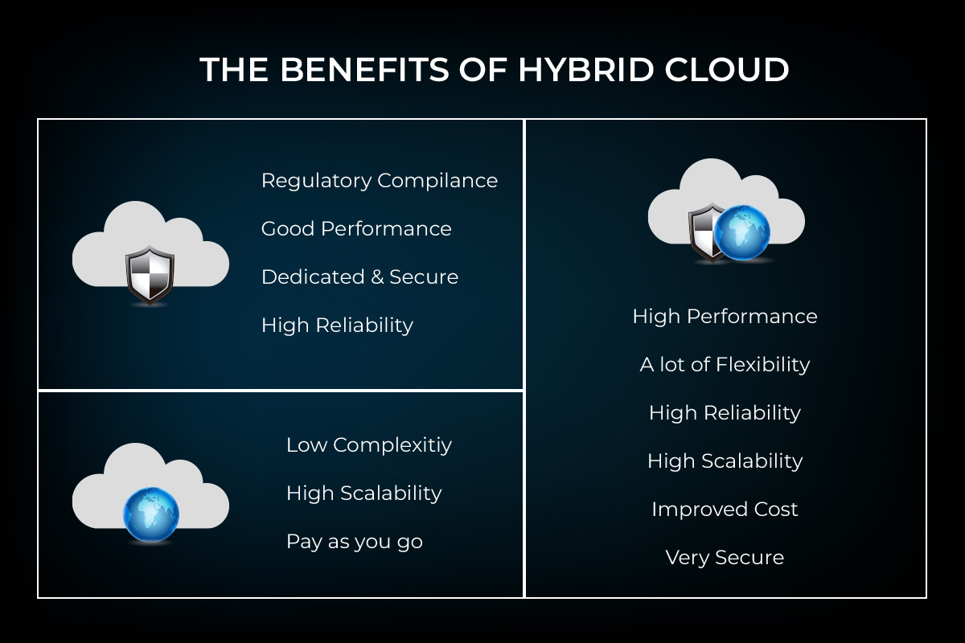

How

The hybrid cloud service provider that we should go with is Microsoft. Azure is Microsoft's cloud computing platform that comprises a collection of software services that can be hosted outside the traditional company IT infrastructure and provides an avenue to getting started quickly building and hosting software, in a flexible pricing business model. With microsoft, we can identify workloads that we can move to Microsoft Azure and decide which assets to keep on-premise. While AWS, Google, and VMware are all pretty good, Microsoft will bring a satisfactory service and provide the best prices for our needs. “Microsoft is set to make Windows Server 2019 generally available in the second half of the year, opening up access to its preview build through its Insiders program now and targeting data centers with new features to handle hybrid cloud setups and hyperconverged infrastructure.” Microsoft is focusing on providing the best experience with their new server update in order to start providing Hybrid-cloud solutions to both big and small companies.

In the next few months we can start planning and integrating Microsoft's Hybrid cloud solutions, so that we can start expanding our company. With the start of Microsoft’s hybrid cloud solution, we can start off with 12 months of free storage risk free just to see how we like the switch. Microsoft Azure is a great solution that gives us the control that we need, it is cost effective, provides flexibility, and it allows us to transition slowly and migrate very gradually. Another portion that we need to be aware of is being able to integrate the public cloud and private cloud seamlessly and depending on the options Juniper networks could be the best option for us. “With workloads moving around public and private cloud, the ability to visualize the virtual private network and manage security policies in a hybrid cloud environment is becoming very important. Juniper Security Director provides improved monitoring capability to visualize VPN status, topology and detail. Along with the ability to visualize the firewall and threat around the private and public cloud environment help to protect the network from being attacked.” (Ko).

Drawbacks

Although there are a lot of advantages to having a hybrid cloud, there are also a few drawbacks that could cause our company a lot of trouble in the future. Dependency is a big one, and if there are any problems with the network for either the public cloud or our private cloud it could cause some downtime for our company to get back up and running. We also must make sure that we are in sync with the third party to ensure that we are protected against malware. Both parties must ensure that all services in use are in line with the company’s security policy, to protect the business’s data and assets against any misdemeanors. The only other drawback would be the complexity of the networks working back and forth. With the complexities of a hybrid cloud platform if there is anything that goes wrong all the advantages for a hybrid solution seems to disappear.

Conclusion

As you can see, using Microsoft Azure as our Hybrid cloud provider will help increase our data speed and productivity by having our hybrid networks configured to push essential data through private servers instead of public ones, greatly improving load times and data transfer speeds. We will also be provided with a much higher security of our data, but at the same time will be able to have a greater control of our spending. Because of the advantages being greater than the drawbacks, I believe that we should take advantage of the Hybrid cloud solution and with the care of Microsoft's team we can be provided with a great service at a lower cost than what we would get with another service. In conclusion, as we are beginning to grow, we need a better solution than having our servers at our headquarters. We need to figure out how to stop our server from lagging and find a solution for when the headquarters go offline so we can seamlessly collect our data from the other buildings without having to switch over to manual recording of our data. This process may take some time, and we need to be careful when implementing the Hybrid cloud solution, but in the end I feel like it will save us money and give us the most flexible solution out of everything.

Works Cited

Mangat, Mona. “What Is Hybrid Cloud? Benefits of Hybrid Architecture.” Main Site, 27 Feb. 2020, phoenixnap.com/blog/what-is-hybrid-cloud.

“Windows Server 19 Embraces Hybrid Cloud, Hyperconverged Data Centers, Linux.” Networks Asia, Mar. 2018, p. 1–N.PAG. EBSCOhost, search.ebscohost.com/login.aspx?direct=true&AuthType=ip,shib&db=bsu&AN=128636361&site=eds-live.

Jain, Tarun, and Jishnu Hazra. “Hybrid Cloud Computing Investment Strategies.” Production & Operations Management, vol. 28, no. 5, May 2019, pp. 1272–1284. EBSCOhost, doi:10.1111/poms.12991.

Morar, Mahindra. Robust Cloud Integration with Azure. Packt Publishing, 2017. EBSCOhost, search.ebscohost.com/login.aspx?direct=true&AuthType=ip,shib&db=nlebk&AN=1489533&site=eds-live.

Carol Ko. “INTEGRATION UNLOCKS HYBRID CLOUD BENEFITS: Technologies and Best Practices to Unify Orchestration of Private and Public Clouds.” ComputerWorld Hong Kong, 2017 4th Quarter 2017, pp. 41–43. EBSCOhost, search.ebscohost.com/login.aspx?direct=true&AuthType=ip,shib&db=iih&AN=127750511&site=eds-live.